CHAPTER 1
INTRODUCTION
The project designed is W-World, a text editor. In general, Text editor is a type of program used to edit plain text files and text in files. Text editor is often provided with operating systems or systems of software development packages, and can be used to configure files and programming Language source code. Various text editors are available in the market such as VI editor and Emacs editor in UNIX, Simple Text and TextEdit editors in Macintosh, Notepad in Microsoft Windows, and so on.
The text editor can be Graphical User Interface (GUI) based or Command User Interface (CUI) based.GUI based application provides readymade options for the long commands to perform a task. It also provides interaction of user with system with mouse click. CUI based application allow user to interact with system only through typing of commands. In these, applications user have to memorize the commands for each task, otherwise they cannot interact with system. For this reason, GUI based application is always preferred over a CUI based.
Notepad is the most common text editor used by almost all computer literate people. It is used to create simple documents. It saves files in plain text format (ANSI text) and supports only a few formatting options. It is used to view or edit text files and text in files (files having the extension .txt). Users find Notepad an ideal tool for creating Web pages. Though Notepad is one of the few tools that have been a part of the Windows operating system since the beginning, it has not evolved much since its initial release. Undoubtedly, Notepad is simple to use, but still lacks many features and enhancements.
W-World is a GUI based application. Some features that lack notepad are tried to add in this application.
Features of W-World:
W-World, a text editor that provides basic features as follows:
- String Searching – Search string in document by typing string in Find.
- Cut, Copy and Paste – Provide methods to duplicate and move text within the file, or between files.
- Multiple font colors – The editor provides different font colors to make a text more interactive and attractive.
- Multiple text background colors – The editor provides different colors to make a text background more interactive and attractive.
- Fonts – The editor provides all fonts that can be used to make a text more appealing.
- Toolbar – The editor provides a very interactive graphical user interface in which it includes a Toolbar. The Toolbar consist of those options which are in frequent use, for example, save, open, cut, copy, paste, print, etc.
- Format bar – The editor also provides a Format bar in order to provide interactive, easy GUI. The Format bar consist of those options which provide facility of formatting text in file, for example, different font names, font styles, text color, background color, alignment, etc.
- Status bar – The editor include the main Status bar. This provides information bout line count, character count (with spaces) in document. It also display names of lock buttons (caps lock, num lock, scroll lock) if they are on.

CHAPTER 2
PROJECT PLAN
Project plan includes planning about development of a project. It includes planning working, schedule and implementing various modules in project. Planning includes what to do, how to do, when to do and who will do it. To plan about project helps us to make the project successfully.
First of all we discussed about the project and goals to be achieved. Then we decide who will design which module. We planned afterwards how to implement different modules. Firstly we create graphical user interface, secondly Menu bar module in which we create different menus file menu, edit menu, insert menu, view menu, format menu, help menu modules.
After studying all Menu bar modules, we create tool bar menu module in which we add different frequently accessed options such as save, new, cut, copy, etc. After that we create Format bar module on which we add different options for text formatting such as font styles, font size, alignment, font color, etc.
After this Status bar design is done which provide line count, character count (with spaces), and mouse position. It displays caps lock, num lock, and scroll lock name if they are on and otherwise are not displayed.

CHAPTER 3
PROJECT REQUIREMENTS
3.1 Requirement Analysis:
Analysis means studying different aspects of the system and working of the system. It also includes the mutual interactions of the different parts of the system.
Analysis is the most important phase in the cycle of a system. In analysis phase one has to study the existing system in detail and also collect necessary information’s regarding the system to be designed so that new system to be developed can be made much easier than the working ones. Hence in this phase flowchart or DFD are made indicating the data flow in the system then only can a system be made correct otherwise it may be incorrect.
Objective of requirement analysis:
- Identify the customer’s need
- Evaluate the system concept for feasibility
- Perform economic and technical analysis.
- Allocate function to hardware, software people database and other system elements
- Establish cost and schedule constraints
- Create a system definition that forms the foundation for all subsequent engineering work.
3.2. Software Requirement for implementation-
- Operating System : Windows XP , win -7
- Software :Java Software Development Kit (JDK1.4 & next)
3.3. Hardware Requirement for implementation
- PROCESSOR : Any Processor
- Monitor : SVGA Color monitor
- Hard Disk : 300 KB
- RAM : 128MB
CHAPTER 4
PROJECT DESIGN
4.1 Feasibility Study:
Preliminary investigation examines project feasibility the like hood the system will be useful to the organization. The main objective of the feasibility study is to test the Technical, Operational and Economical feasibility for adding new modules and debugging old running system. All systems are feasible if they are given unlimited resources and infinite time. There are aspects in the feasibility study portion of the preliminary investigation:
- Technical Feasibility
- Operational Feasibility
- Economical Feasibility
4.1.1 Technical Feasibility
The technical issue usually raised during the feasibility stage of the investigation includes the following:
- Does the necessary technology exist to do what is suspected?
- Does the proposed equipment have the technical capacity to hold the data required to use the new system?
- Can system be upgraded if developed?
4.1.2 Operational Feasibility
Operational Feasibility aspects of the project are the project are to be taken as important part of the project implementation. Some of the important issues raised to test the operational feasibility of a project includes the following:-
- Is there sufficient support for the management from the user?
- Will the system be used and work properly if is being developed and implemented?

4.1.3 Economical Feasibility
A system can be developed technically and that will be used if installed must still be a good investment for the organization. In the economical feasibility, the development cost in creating the system is evaluated against the ultimate benefits derived from the new systems. Financial benefits must be equal or exceed the costs.
4.2 Functional and Behavioral Description:-
W-World text editor looks as shown in Figure 4.1 after opening. W-World, the Text Editor consists of menu bar toolbar, format bar, text area and status bar by default at the time of opening.
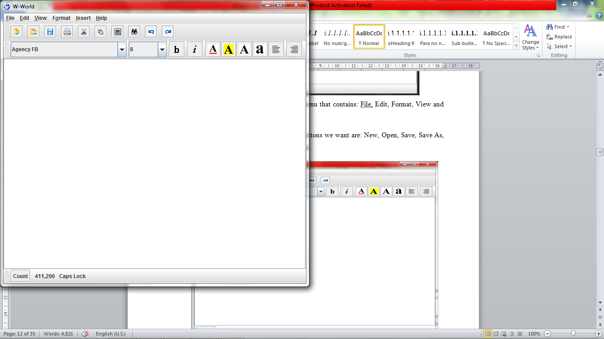
Figure 4.1 W-World Editor View

4.2.1 Menu Bar –
W-World has a menu bar that contains: File, Edit, Insert, Format, View and Help menus.
- File Menu –
File Menu is specially made for operations on files. The options added in file menu are: New, Open, Save, Save As, Page Setup, Print and Exit as shown in figure 4.2.
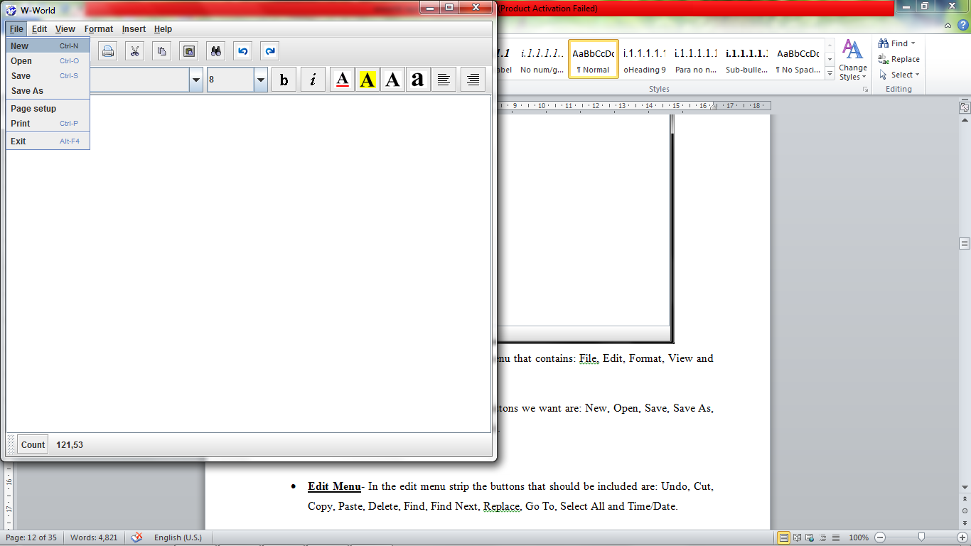
Figure 4.2 File Menu View

- Edit Menu –
Edit option provide options to perform operations on text. In the edit menu, the options that are included are: Undo, Redo, Cut, Copy, Paste, Find, Replace as shown in figure 4.3.
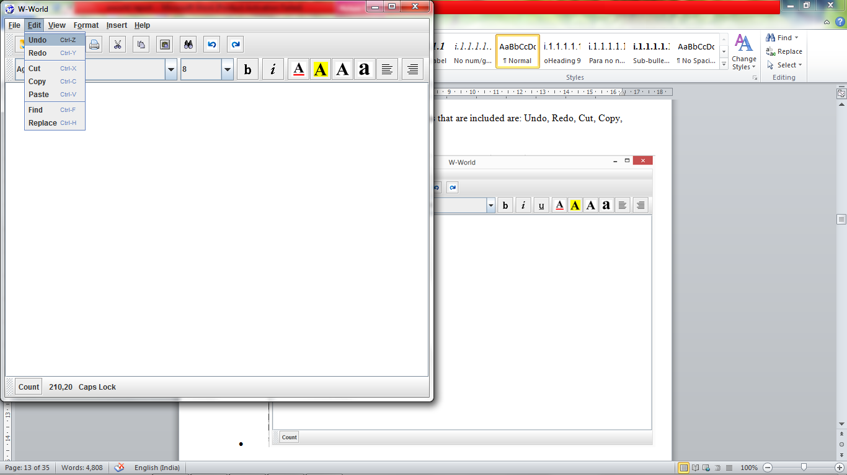
Figure 4.3 Edit Menu View

- Format Menu –
Format menu options helps to format the text in documents. The options provided in the format menu are: Word Wrap and Font as shown in Figure 4.4.
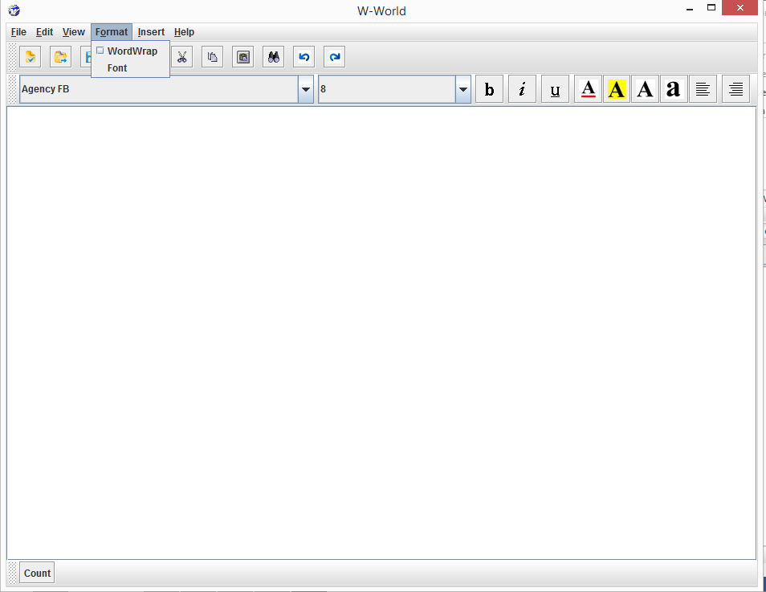
Figure 4.4 Format Menu View

- View Menu –
The View Menu contains options to hide or unhide the facilities Tool bar, Format bar, and Status bar. It contains checkable Tool bar, Format bar, Status Bar options as shown in figure 4.5. these options can be unchecked to hide the bars.
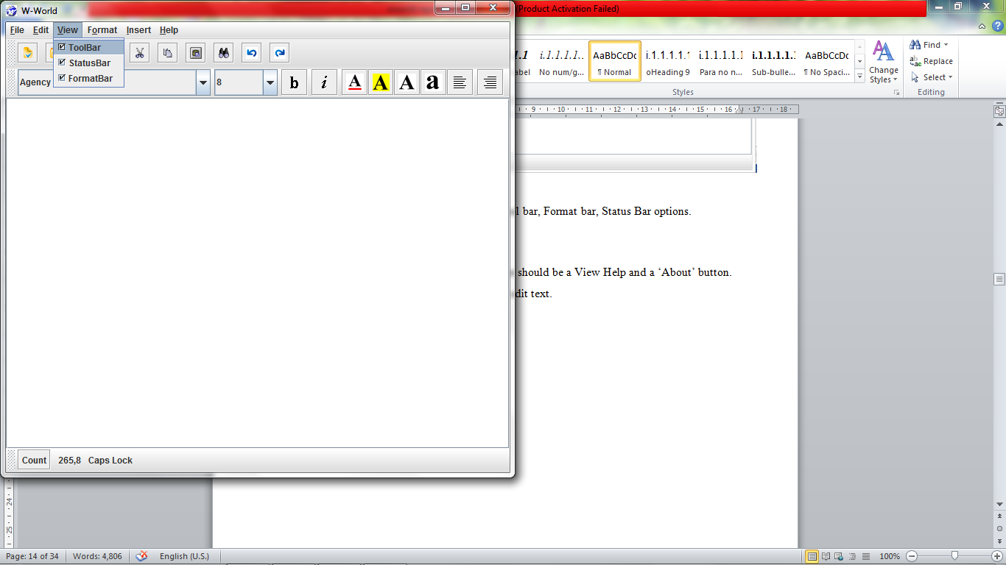
Figure 4.5 View Menu View

- Insert Menu –
Insert menu as name suggests helps to insert date and time in the document. Insert Menu provides options Date and Time as shown in figure 4.6. These options insert date and time in simple format at the end of the text.
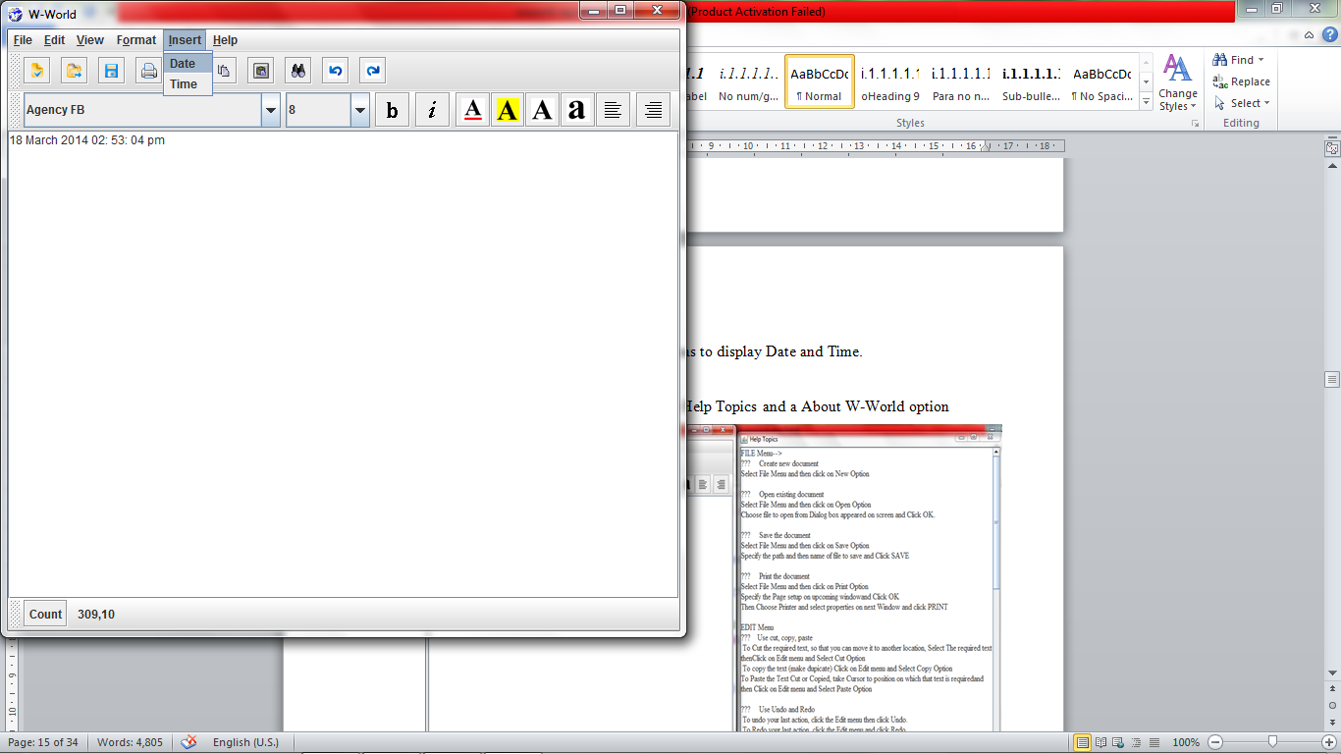
Figure 4.6 Insert Menu View

- Help Menu –
In the Help menu there are Help Topics and About W-World option as shown in figure 4.7.
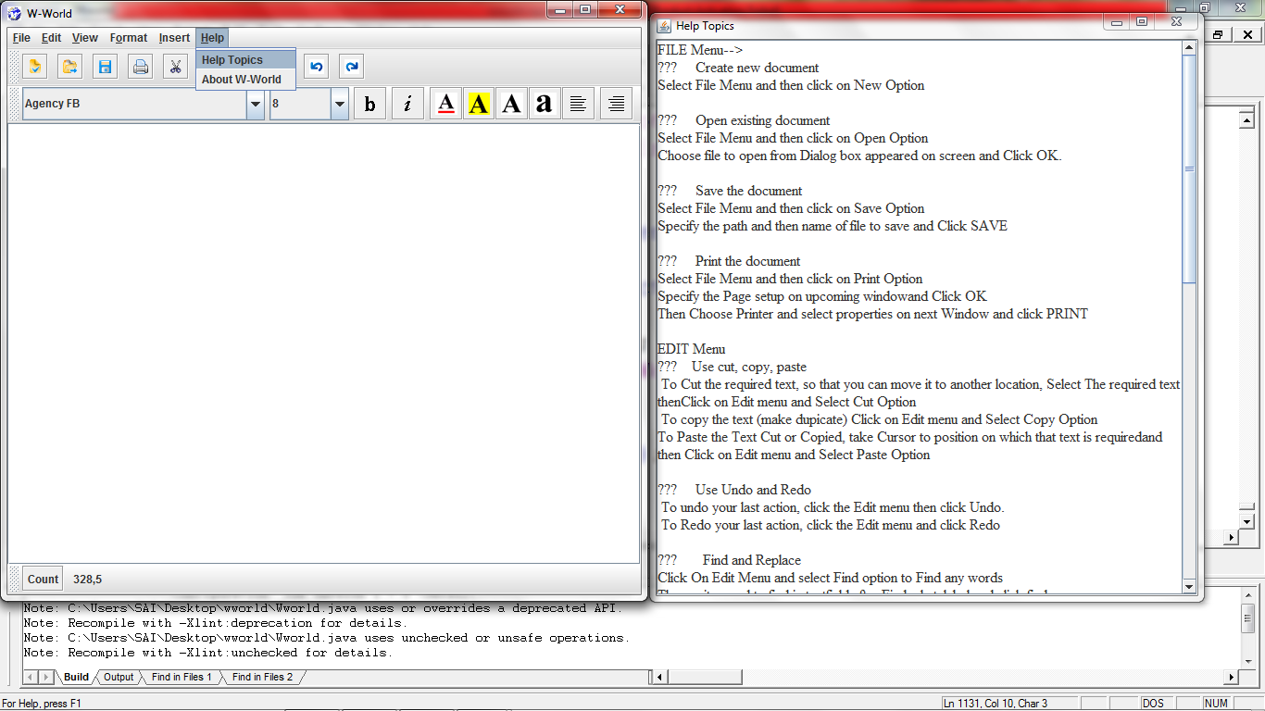
Figure 4.7 Help Menu View
1) FILE MENU --
- New File –
This option allows user to create a new file and perform various functions on that file. When the user clicks on to the editor icon on the screen, the request is sent to the OS and it is processed by opening the editor screen on the desktop which allows the user to type the required text on the newly created file, edit and perform various operations on the same.

- Open File –
This option allows the users to open an already existing file. We should make sure that the file is already available in the hard disk of the system being used. The user inputs the name of the file using the keyboard or by selecting the required file in the dialog box. The filename is sent to the hard disk and if file is found, the file is displayed on the editor. Now the file is ready for all text manipulations like cut, copy and paste.
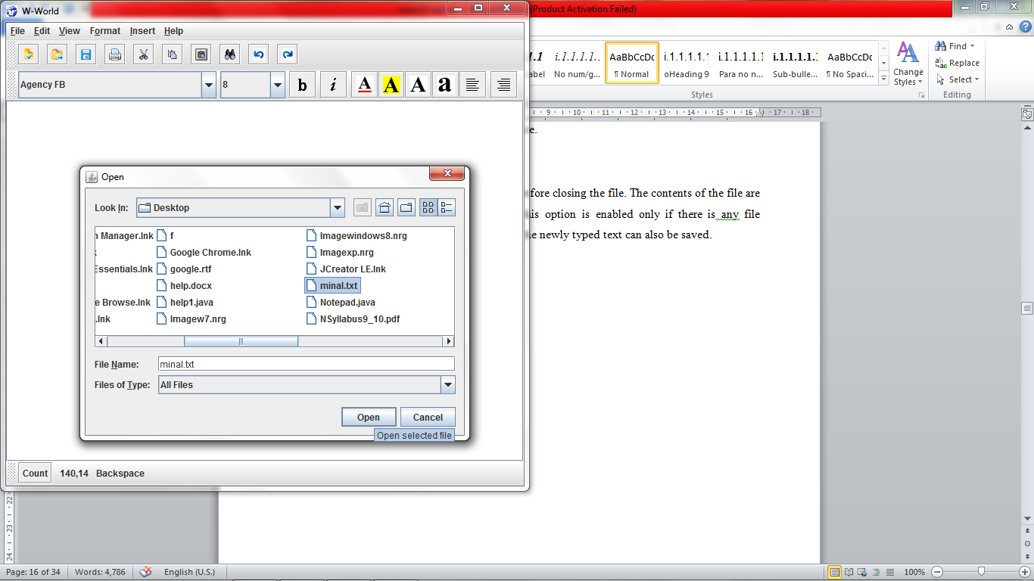
Figure 4.8 Open Dialog
- Save File -
This is a usual operation which is performed before closing the file. The contents of the file are saved at any specified location on the disk. This option is enabled only if there is any file which is already opened. In the similar fashion the newly typed text can also be saved.
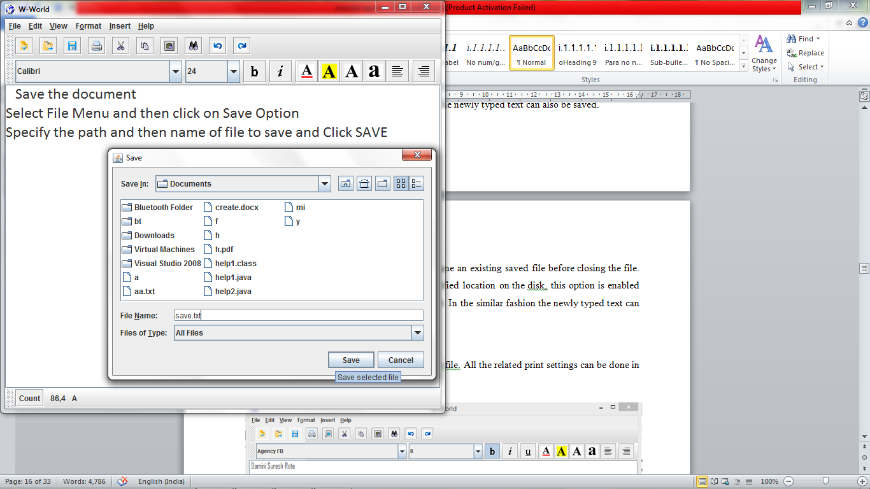
Figure 4.9 Save Dialog
- Save As -
This is a usual operation which is used to rename an existing saved file before closing the file. The contents of the file are saved at any specified location on the disk. This option is enabled only if there is any file which is already opened. In the similar fashion the newly typed text can also be saved.
- Page Setup -
This option helps to set the page for printing. This set page is then passed to print page format and after giving print the text is printed as page size given in page setup option.
- Print :-
Print option provides facility to print the current document.
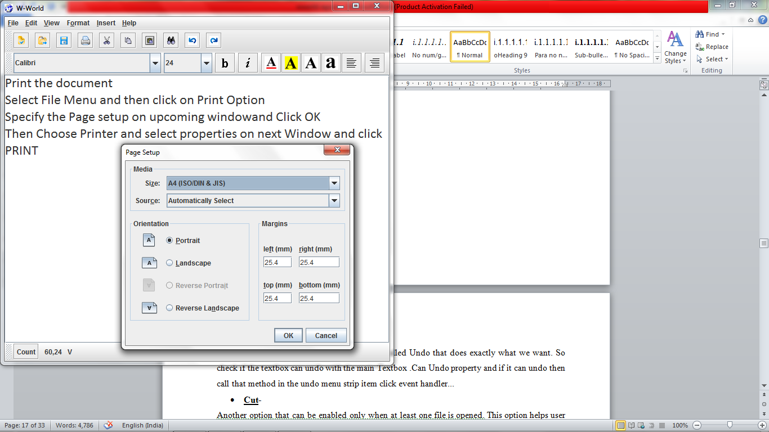
Figure 4.10 Page Setup
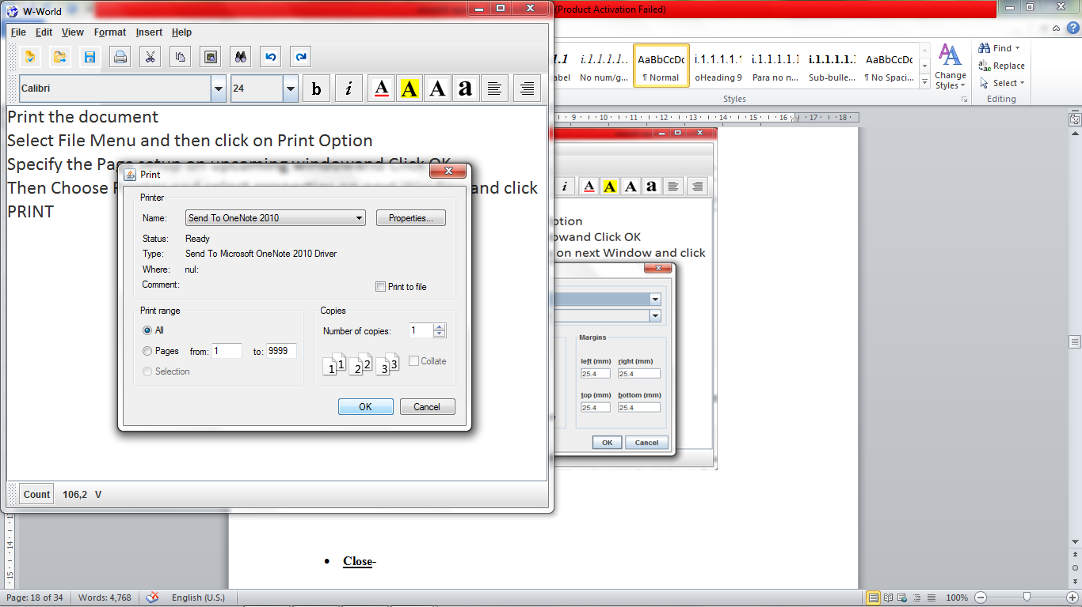
Figure 4.11 Print Dialog
- Exit-
This option is used to close the application.
2) EDIT-
- Undo & Redo -
To undo your last action undo option is used whereas to Redo your last action Redo option is used.
- Cut -
This option helps user to edit the text. Here the user has to select the particular text that is to be cut before performing this action. When the “cut” option is chose the selected text is saved in a separate location, say a clipboard and the text disappears from the place where it was originally found.
- Copy -
Using this option Selected part of text is copied into a clipboard leaving the copied text at same place.
- Paste -
This option is enabled only when a “Cut” or “Copy” is already performed. It allows the user to insert text from the clipboard where the cut or copied text is saved, into the current file. .
- Find -
This option will find a particular text that the user wants to search in the current document.
- Replace -
This option will replace the selected text with the new text specified by the user.
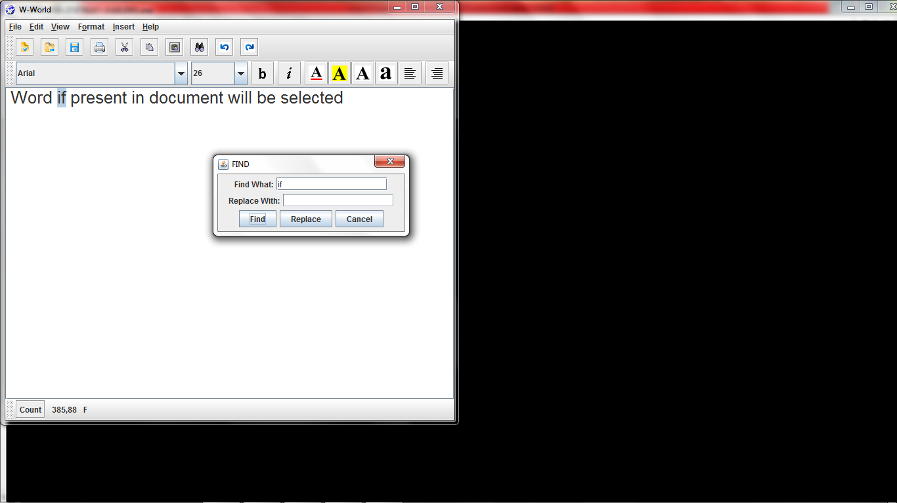
Figure 4.12 Find Dialog
3) FORMAT-
- Word Wrap-
Word Wrap means it will make the text fit into the text box in horizontal manner, it won’t go beyond the text box frame in horizontal.
- Change the Font -
Font option will show a window that contains options like Font, Italic, Bold, etc. A list of fonts will be displayed at one side of the box and on the other side different font expressions like Bold, Regular, Italic and Bold Italic are also displayed. Font Dialog box is as shown in Figure 4.13 and the Text formatting done using it is shown in Figure 4.14.
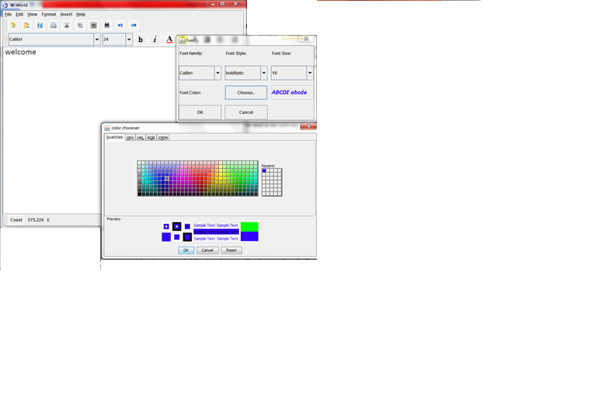
Figure 4.13 Font Dialog

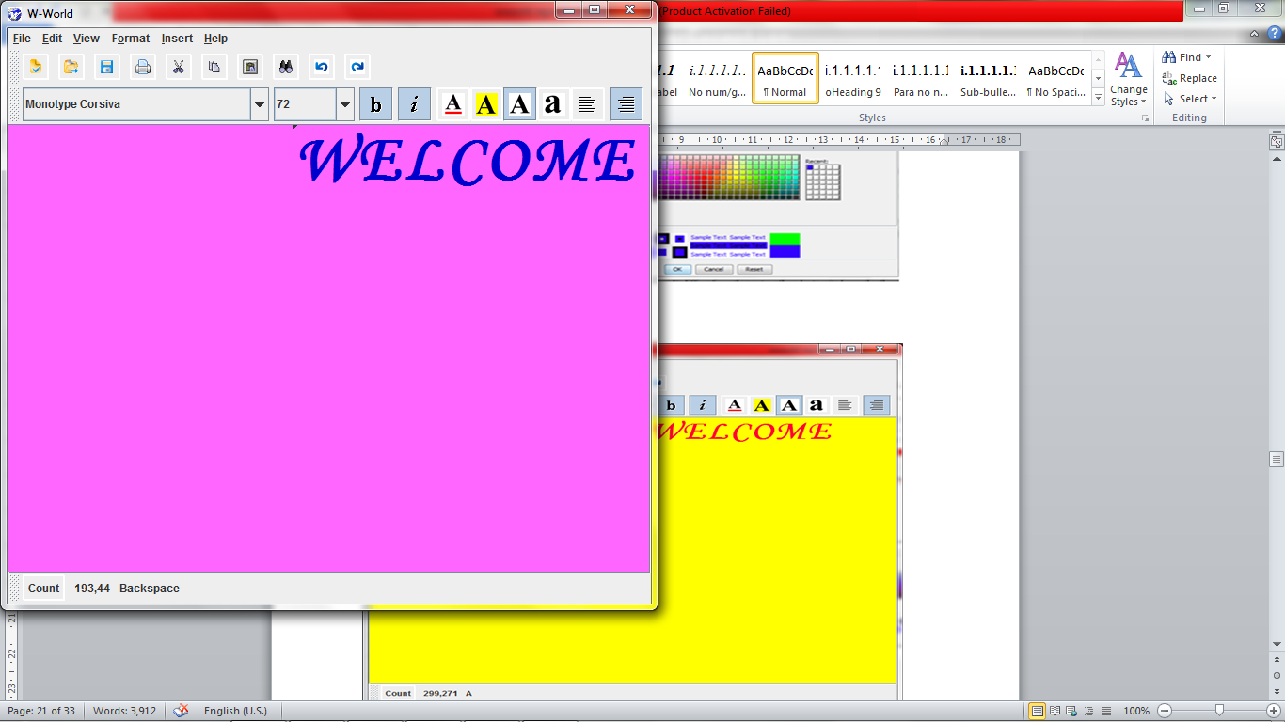
Figure 4.14 Text Formatting
Popup menu -
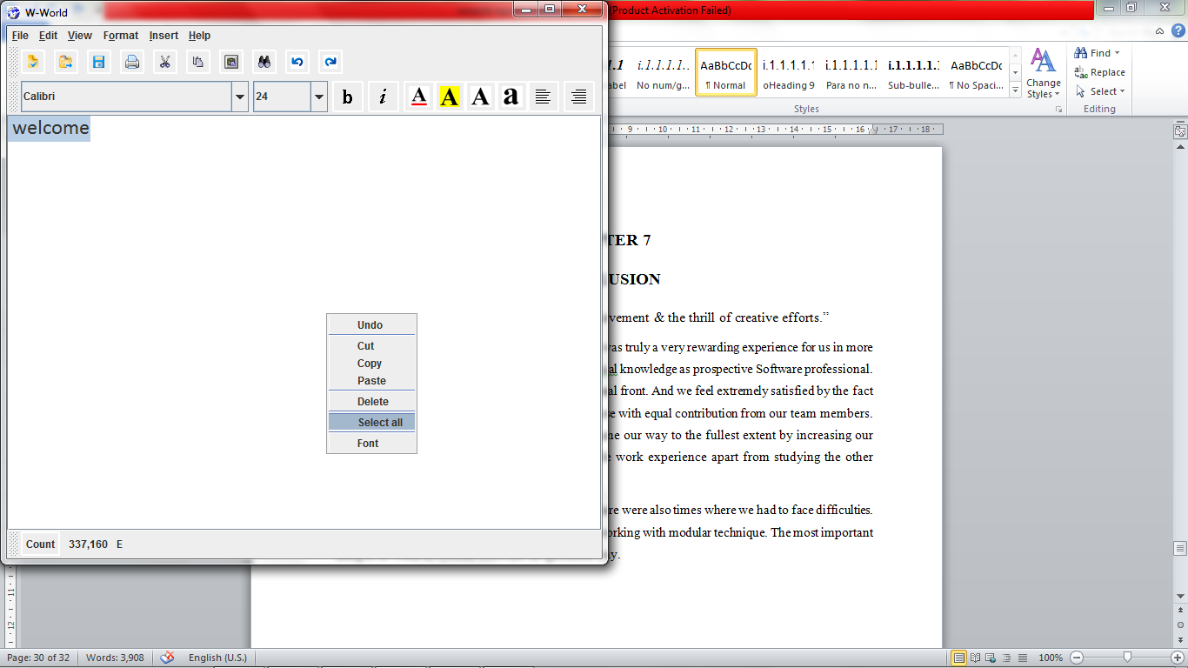
Figure 4.15 Popup Menu
4.3 Data Flow Diagram
A data flow diagram (DFD) is a graphical representation of the "flow" of data through an information system. It differs from the system flowchart as it shows the flow of data through processes instead of hardware. A data flow diagram can also be used for the visualization of data processing (structured design).
Data Flow Diagram is a graphical representation that depicts information flow and the transform that are applied as data move from input to a output. The basic form, of dataflow diagram also known as data flow graph. DFD used to represent software at any level of abstraction DFDs may be partition into levels that represents increasing information flow and functional detail.

Item | Representation | Meaning
External entity | A rectangle | A producer or consumer of information that is outside the process being modeled.
Process or activity | A circle | A transformer of information that is within the scope of the system being modeled.
Data (flow) | A line with an arrowhead that indicates the direction of data flow | The input to, or output from, a given process, which is associated with each arrow in a DFD.
Data store | Two parallel lines with the name of the data store between them. | A repository of data for use by one or more processes.

Table 4.1: DFD Notation
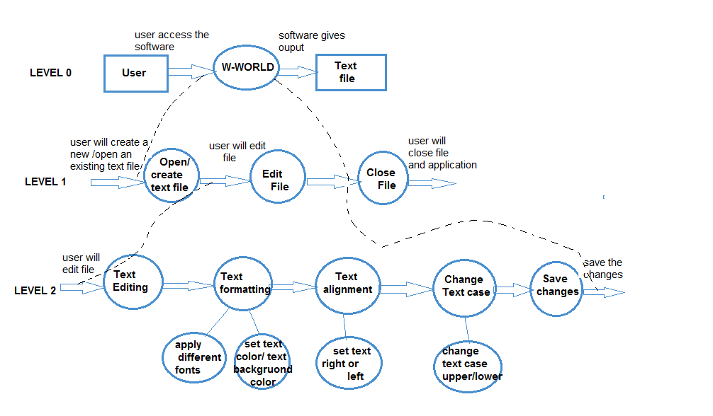
Fig 4.16 Data Flow Diagram for W-World.
Level 0 DFD:
At level 0 DFD, the user requests the W-World software to access it and perform various functions. As a result of which, the W-World software will generate the user’s desired output. The output either may be an image file or a text file.
Level 1 DFD:
At level 1 DFD, the operations performed by the software are mentioned. First of all, the software will either create a new text/image file or open an existing text/image file. Secondly, the user will perform editing in the file according to his convenience.
Level 2 DFD:
At level 2 DFD, the operations performed in the Edit text file process and formatting process is explained more clearly. The user will do the editing in the text file and then he will save the changes made in it. In formatting process user can apply different font styles ,font size, text color ,background color and also alignments.
4.4. E-R Model Diagram-
The most useful thing in this model is, it allows us to represent data in the form of a diagram popularly known as E-R diagram and from this diagram we can map the data into a relational schema.
In the Entity relation, it shows the relation between different entities of system. In this system, there are three main entities such File, Edit, Image, Security, Format and W-World is main process by which these entities are related.
In this project design, the File Menu has attributes as New, Open, Save, Save As, Print and Exit. The Edit has attributes as Undo, Redo, Cut, Copy, Paste, Find, and Replace. Format menu has options Font and Word wrap as attributes. Insert Menu consists of date and time attributes. And the option View has attributes Toolbar, Status bar, Format bar. Also help menu in the project has attributes help topics and about w-world.

Item | Definition | Example
Entity | Any real world object that has some well-defined characteristics. | Employee, Professor, Department, Student, Course etc.
Property (or) Attribute | Any characteristic of an entity. | For example an employee has a name, ID, department etc.; A professor has name, the subject he teaches, the department he belongs to etc.; A department has a name, number of employees etc.; A student has a name, id and class he belongs to; A course has a name, course number etc.
Relationship | Association among entities or an entity that helps to connect two or more other entities. | Registration (connects student and the course entities)  Project ( connects employee and department entities)
Regular Entity | An entity which is independent of other entities. | Course is a regular entity.
Weak Entity | An entity which is dependent on some other entity. | Section is a sub type of Course. i.e. a course has many sections. Without a course there is no section.

Table 4.2: E-R Model Notation
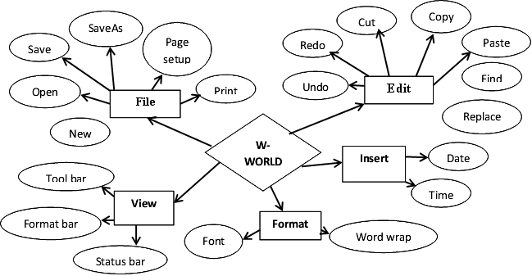
Fig 4.17 Entity Relationship Diagram

4.5 Flowchart-
A flowchart is a type of diagram that represents an algorithm or process, showing the steps as boxes of various kinds, and their order by connecting these with arrows. This diagrammatic representation can give a step-by-step solution to a given problem. Process operations are represented in these boxes, and arrows connecting them represent flow of control. Data flows are not typically represented in a flowchart, in contrast with data flow diagrams; rather, they are implied by the sequencing of operations.
Click Open option
Select file/ Enter name of the file to open
Open desired file.
File does not exists
File exists?

Click on Save option
Enter the name of file by which you want to save it
Select type of file
Click Save button
Fig. 4.18 Save option flowchart Fig.4.19 Open option flowchart

4.6. Activity diagram-
What is activity diagram?
Activity diagram is another important diagram in UML to describe dynamic aspects of the system.
Activity diagram is basically a flow chart to represent the flow form one activity to another activity. The activity can be described as an operation of the system.
So the control flow is drawn from one operation to another. This flow can be sequential, branched or concurrent. Activity diagrams deals with all type of flow control by using different elements like fork, join etc.

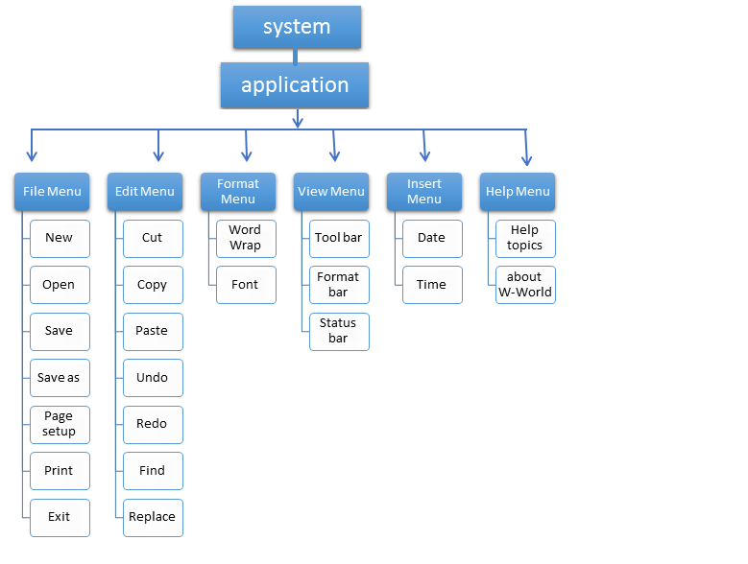
Fig 4.20 Activity diagram
In the above Activity diagram, the System is associated to the Application. The Application box has a number of menus like File, Edit, Format, Insert, view and Help. Each menu is shown with its different functions and options in Fig.4.20. For File menu, its functions are New, Open, Save, Save As, Print, Exit. For Edit menu, its functions are Undo, Redo, Cut, Copy, Paste, Find and Replace. Similarly for Format Menu functions are word wrap and font. For View menu Tool bar, Status bar and Format bar. And for Insert menu the functions are Date and Time.

CHAPTER 5
SYSTEM DEVELOPMENT
Development includes all those activities that takes place to convert from the old system to the new. Development is the process of having system personnel check out and put new equipment into use, train users, install the new application and construct files of data needed to use it. Development is a process of going toward the progress. It is indicator that shows the direction of completions.
Here in our project we have planned how to implement different modules. Firstly we create graphical user interface, secondly Menu bar module in which we create different modules file menu, edit menu, view menu, insert menu, format menu, help menu modules.
After studying all Menu bar modules, we create tool bar menu module in which we add different frequently access options such as save, new, cut, copy,etc. Here in our project we create Format bar module on which we add different options for text formatting such as font styles, font names, font size, alignment, etc.

CHAPTER 6
SYSTEM TESTING AND MAINTENANCE

Testing
Once the code is generated, the software program testing begins. Different testing methodologies are available to unravel the bugs that were committed during the previous phases. Different testing tools and methodologies are already available. Some companies build their own testing tools that are tailor made for their own development operations.
The main types of Texting are:
- Static Black Box Testing
- Static White Box Testing
- Dynamic Black Box Testing
- Dynamic White Box Testing
Testing is done using automation tools to speed up the testing and find more bugs in less time. But we use the method to test the software is to test the software by giving text cases manually.
We tested open option by opening different format files in this editor. New option is checked by repeatedly giving new instruction after some formatting. Save option is checked by saving the files and opening those saved files. Print option is also checked via giving different different page commands.
We tested options in edit menu by performing those operations on various texts. Repeatedly done actions are giving trouble or no is also tested during testing.
Checkable items in view menu are performing their operations correctly or not is tested by observing the result as hide or unhide of tool bar, format bar and Status bar.
Insert menu inserts date and time, but it is placing it in correct place and in correct format or not is tested by giving text and then inserting it and also at the time of blank text area it is inserted and observed.
Scrolling is attaching to text area when needed is tested with word wrap option that removes horizontal scrolling.
When we get proper result then and only then it is placed in the application.
Maintenance
Software will definitely undergo change once it is delivered to the customer. There are many reasons for the change. Change could happen because of some unexpected input values into the system. In addition, the changes in the system could directly affect the software operations. The software should be developed to accommodate changes that could happen during the post implementation period.

Chapter 7
conclusion
“Happiness lies in the joy of achievement & the thrill of creative efforts.”
The project “W-World” that we undertook was truly a very rewarding experience for us in more than one way. It has given a big thrust to our technical knowledge as prospective Software professional. It has also helped us enhance our skills on the personal front. And we feel extremely satisfied by the fact that we have managed to develop the project of course with equal contribution from our team members. We think we have exploited the opportunity that came our way to the fullest extent by increasing our technical know-how and also gaining the valuable work experience apart from studying the other subjects in our curriculum.
It must all together smooth going process there were also times where we had to face difficulties. We learnt to work in team spirit,division of work, working with modular technique. The most important thing is to work in system software in specified way.

chapter 8
FUTURE ENHANCEMENT
In W-World software there will be many new updates available and then those updates can added into this software as new features later on. These updates are the new improvements or technologies done in the field of this software.
The following are the possible future enhancements that can be done in this software-
- New image editing options-
In the same way as mentioned above, new image editing options may be added to the software. Many image related effects such as combination of some colors, Sepia, Solaris, False colors may be added later on to this software. Also, if there are any new features regarding image editing, they can be added to the software.
- New Security techniques-
As we all know that any security technique/algorithm may be broken due to which any secured file may be cracked easily. In order to avoid this, the software must be updated with any new encryption technique that comes into existence. If the software has proper security mechanism, then its data will remain secured.

CHAPTER 9
REFERENCES
- Books –
- Java the Complete Reference : Herbert Shield – Tata McGraw Hill
- Java 2 programming Black Book- Steven Holzner et al. – Dreamtech Press
- Complete Reference- A Practitioner’s Approach By Roger Pressman

- Websites –
- http://docs.oracle.com

